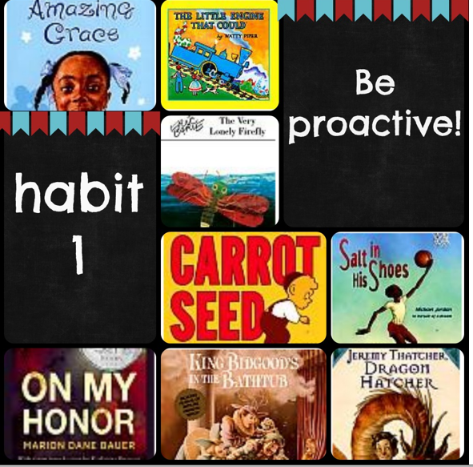
Amazing Grace by Mary Hoffman
The Little Engine That Could by Watty Piper
King Bidgood’s in the Bathtub by Audrey Wood
The Very Lonely Firefly by Eric Carle
The Carrot Seed by Ruth Krauss
Salt in His Shoes by Michael Jordan
Jeremy Thatcher, Dragon Hatcher by Bruce Coville (chapter book)
On My Honor by Marion Bauer (chapter book)
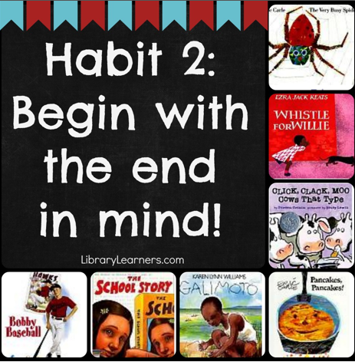
The Very Busy Spider by Eric Carle
Whistle for Willie by Ezra Jack Keats
Click, Clack, Moo by Doreen Cronin
Pancakes, Pancakes by Eric Carle
Galimoto by Karen Williams
Bobby Baseball by Robert K. Smith (chapter book)
The School Story by Andrew Clements (chapter book)

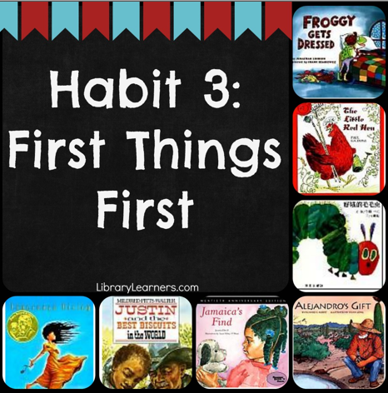
Froggy Gets Dressed by Jonathan London
The Little Red Hen by Paul Galdone
The Very Hungry Caterpillar by Eric Carle
Alejandro’s Gift by Richard E. Albert
Jamaica’s Find by Juanita Havill
Justin and the Best Biscuits in the World by Mildred Pitts Walter
Esperanza Rising by Pam Munoz Ryan (chapter book)
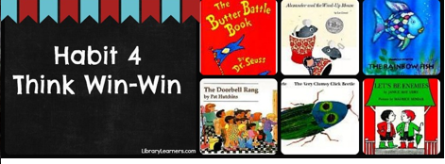
The Butter Battle Book by Dr. Seuss
Alexander and the Wind-Up Mouse by Leo Lionni
The Rainbow Fish by Marcus Pfister
The Doorbell Rang by Pat Hutchins
The Very Clumsy Click Beetle by Eric Carle
Let’s Be Enemies by Janice May Udry

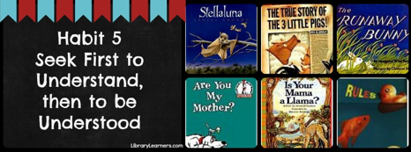
Stellaluna by Janell Cannon
The True Story of the Three Little Pigs by Jon Scieszka
The Runaway Bunny by Margaret Wise Brown
Are You My Mother? by P. D. Eastman
Is Your Mama a Llama? by Deborah Guarino
Rules by Cynthia Lord (chapter book)

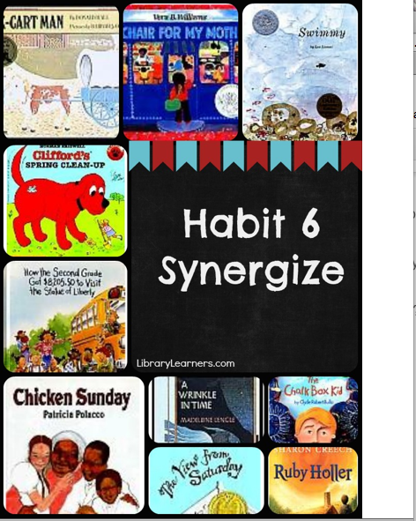
Ox-Cart Man by Donald Hall
Swimmy by Leo Lionni
A Chair for my Mother by Vera Williams
Clifford’s Spring Clean-Up by Norman Bridwell
How the Second Grade Got $8205.50 to Visit the Statue of Liberty by Nathan Zimelman
Chicken Sunday by Patricia Polacco
The Chalk Box Kid by Clyde Robert Bulla (chapter book)
The View From Saturday by E. L. Konigsburg (chapter book)
A Wrinkle in Time by Madeline L’Engle (chapter book)
Ruby Holler by Sharon Creech (chapter book)

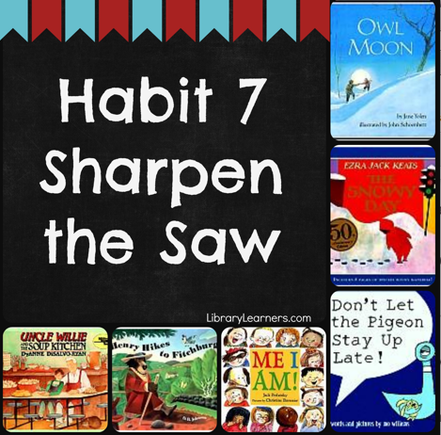
Owl Moon by Jane Yolen
The Snowy Day by Ezra Jack Keats
Don’t Let the Pigeon Stay Up Late by Mo Willems
Henry Hikes to Fitchburg by D. B. Johnson
Me I Am! by Jack Prelutsky
Uncle Willie and the Soup Kitchen by DyAnne DiSalvo Ryan

